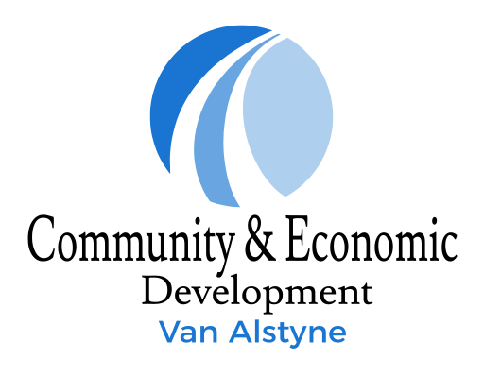
OFFICE USE ONLY
DATE RECEIVED FROM APPLICANT: _________________
Van Alstyne CDC
152 N Main Drive
P. O. Box 2151
Van Alstyne, Texas 75495
(903) 712-2002

RETENTION and EXPANSION GRANT
NOTICE OF PROJECT COMPLETION FORM

Applicant and Property Information
Applicant’s name (print): _____________________________________________________________________
Applicant’s telephone number: ________________________________________________________________
Organization’s name: ___________________________________ ____________________
Property address of project: ___________________________________________________________________
Project Information
Description of improvements: _________________________________________________________________
__________________
__________________
Requested grant amount: $ ________________
Contractor’s name and telephone number: ______________________________________________________
__________________
Date of project completion: ________________
I read the Retention and Expansion Grant description and agree to all terms contained therein, including compliance with all applicable city, state, and federal codes and the one (1) year maintenance requirement. I understand that this form, along with all original invoices and receipts, serves as a request for inspection and payment.

APPLICANT’S SIGNATURE ____________________________________________________ Date: ___________
Notice of Project Completion Form and final invoices are to be delivered to the Van Alstyne Community Development Corporation office at 152 N, Main Drive, Texas 75495, or submitted electronically at pboatman@cityofvanalstyne.us.

